Section 5 - Post-Prototype Refinement

Feedback & Responses:
To gather feedback on my prototype, I created a form in the format of a table allowing a competent third party to make comments on the prototype I created.
Attribute | User comment
Usability | The GUI is clear and laid out well. It is simple and informative, with clear headings that tell the user what stage they're currently at. I like the dashboards as well. I only tested this as a customer however I was told that there are dashboards for staff and admin members which is also good. It keeps everything organised and simple. The system is semi-usable from a customer perspective, however I couldn't tell if my order had been submitted or not, so I think there were problems with that, but I understand that this is a prototype.
Navigation | I think it's easy to navigate, again with the large and bold headings that inform the user of their progress. But I think it is inconvenient that there are no back buttons, so I have to fully close my window down to move on. I think the text and all the features may need to be a little bit bigger, but that could be just me.
Intuitiveness | It is very intuitive with the headings, however I think some text that tells the user what they have to do could be helpful as they may not know what is expected under each task. For example, when creating order, text stating “Select item and specify the quantity” could be useful.
Help & Guidance | There was no sort of help or guidance. Messages like “Reservation successfully created” or error messages displayed after task outcomes would've been useful, I didn't know if I could move on. There wasn't any labels or prompt to follow through other than the headings, so it could be confusing to some people.
Functionality | The program did some of what is expected like making reservations and creating orders, however these features could definitely be improved to enhance functionality. As I only trialled this as a customer POV, I would say it is quite satisfactory. Although it could be improved and optimised, it is only a prototype.
Suggestions | I think the colours are quite dull though, brighter colours and images could make it look more lively for a restaurant system. Add forward and previous page buttons for better navigation. Add messages to inform the user of their progress on their tasks, including error messages. Also, add some text under each heading specifying the instructions to the user to make it clearer. For the create order feature, put the selection and text in the centre of the page as the current format is odd.
Key Feedback Points:
After receiving this feedback, I learnt about how a competent third party felt about my prototype so far. Gathering feedback early on allows me to make final changes before the final program.
In terms of usability and navigation, suggestions such as adding buttons that allow users to go back to a previous page or move forward with the system came up. This is a feature I will consider because it would improve the usability of the system, allowing users to simply click these buttons instead of having to manually exit the window. This would also reduce the need for multiple windows being opened which could confuse users as it would be hard to organise and keep track off. For this feature, I would simply put the buttons in the bottom left and right of each window, the left for ‘Previous page’ and the right for the ‘Next page’. It would display the text and allow users to go to their desired page. An alternative to this if it is outside of my competence to program would be to have a ‘Return to dashboard’ button that would play a similar role in letting users go to their desired page. I think the ‘return to dashboard’ button idea is more feasible for me, so by implementing this into my final program would satisfy the users need in a similar way.
In terms of the intuitiveness, the suggestion of adding messages after submitting each task to inform them if it was successful or unsuccessful was brought up. This is a feature I will implement into my program as I realised how it was inconvenient for the user. When my third-party user tested the program out, they could not tell if their reservation had been successfully created, leading them to create multiple of the same reservation which is a waste of storage for the system. For this to happen, I must use the ‘messagebox’ library and import this into my program. Despite the ‘create order’ function of the program experiencing issues, it still did not notify the customer if their order had been made and submitted, which would lead to them creating multiple of the same order, overwhelming the system. To prevent these issues, I intend on implementing messages or notifications to the system after each task. Once a user has completed a task with their inputs and pressed ‘Submit’ a little box/window will appear notifying the user of their task outcome’. For instance, if the user submits their order and the data inputs are appropriate, the message will say ‘Order successfully created!”. In the case a task was unsuccessful or failed because of the inputs being incorrect, the message would say “Unsuccessful, please try again!” and allow the user to try again. This will ensure tasks are completed fully to the standard the system requires but also inform the user of their progress to avoid confusion and future complications.
In terms of navigation, I was suggested to change the appearance of the GUI. By using more vibrant colours instead of dull ones, it would increase the user engagement and also be more representative of a restaurant system. I agree with this as the system right now is quite dull and boring, it doesn't resemble a restaurant. I could also add images to the windows. For example, adding images of the cuisine offered at El Aziz would be more aesthetically pleasing but also informative to the users because they would get an impression or idea of the dishes served. However, for this feature to be added the ‘PhotoImage’ library must be imported. Despite being inexperienced with libraries, I am determined to use this library and import images into my program. I was also advised to add short lines of text, instructing the user on what to do. Although the headings are clear on what task they are on, it does not specify what the system would like the user to do. For example, the current ‘Create Order’ function requires the user to select an item and then specify their quantity desired. However, the target market users of this system could be beginners to using systems like this and new to technology in general, therefore this task may not be clear. By adding a short line of text instructing the user to ‘Please select an item and specify the quantity required” it pushes the user in the right direction and is more clear on what data is needed. Moreover, I was also advised to centre the text of selection and entries from the ‘Create Order’ function because the formatting was inconvenient. Learning form this, I will take action on this because I want my system to be intuitive and easy to navigate. I intend on tailoring the system to fit my target user's needs.

Feedback Outcomes:
Welcome to El Aziz!

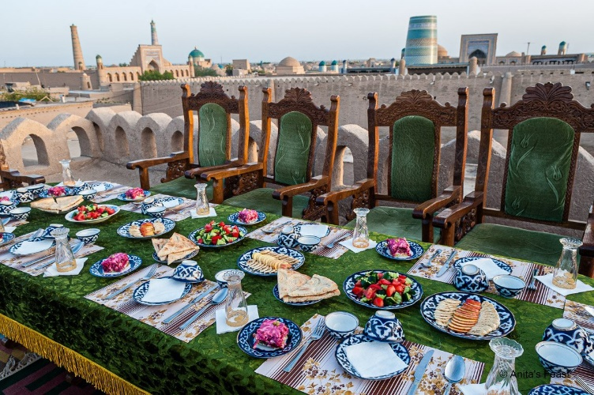
Contact us:
elazizservices@gmail.com
+998 93-945-86-91
Highlighted text to catch user’s attention, implies importance.

Use of vibrant colours. Instead of dull greys and blacks, I have used yellow which is eye catching.
Create Account
Login

Added an image to the background for aesthetic purposes, impresses the user.
Image not fully covering the entire window so it’s less overwhelming and more visible. White space surrounding to ease user.

Use of vibrant colours. Instead of dull greys and blacks, I have used yellow which is eye catching.
Menu:

Sides:
Drinks:
Non - $2.50
Salad - $3.50
Water - $1.50
Soda - $2.00
Choi - $2.00
Main:
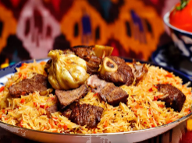
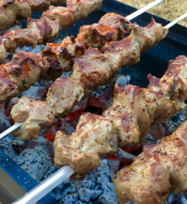
Jizz - $5.00
Pilaf - $6.50

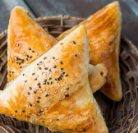
Samsa - $3.50
Shashlik - $4.50
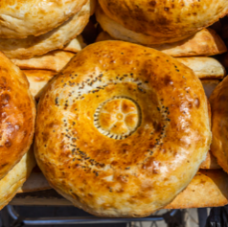
Added images of the cuisine offered to give user an impression but also inform them on the dishes.

Underneath each menu item, a short description will be written to explain the cuisine and paint a rough picture of the food.

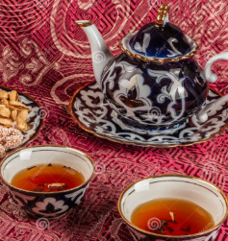
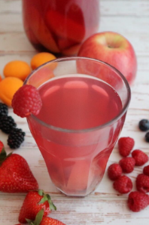
Kompot - $2.00

Return to Dashboard

Return to dashboard button acts as a back button. Allows user to go back to the menu of options and proceed with next task.

Please select an item and specify its quantity, then confirm your order.
Create Order
Short text instructing the user on what to do, simplifies task and makes it clearer.
Jizz - $5.00
0
0
Pilaf - $6.50
0
Samsa - $3.50
0
Shashlik - $4.50
0
Non - $2.50
0
Salad - $3.50
0
Water - $1.50
0
Soda - $2.00
0
Kompot - $2.00
0
Choi - $1.50

All menu items listed, select item you want, specify the quantity (default value is 0) then continue until your order is complete. Uses of selection and entry to gather inputs, instead of drop down menu designed previously.
Additional data required:

Updated data structure tables:

Total automatically calculated and displayed for user to see.
$0.00
Confirm Order
Return to Dashboard

Confirm your order button allows user to submit inputs. If appropriate, message appears to inform them of success. If not, error message displayed.
Return to dashboard button acts as a back button. Allows user to go back to the menu of options and proceed with next task.

Unsuccessful attempt!
Please try again
Order has been successfully created! Please return to the dashboard.

Pseudocode:
The only refinements that requires additional pseudocode is for the addition of images, and the message production.
IMAGES: MESSAGES:
import tkinter as tk
from tkinter import PhotoImage

parent = tk.Tk()
parent.title("El Aziz")

image = PhotoImage(file="pilaf.png")

image_label = tk.Label(parent, image=image)
image_label.pack()

parent.mainloop()
from tkinter import *
from tkinter import messagebox
root = Tk()
root.geometry("300x200")
w = Label(root, text ='El Aziz', font = "50")
w.pack()
messagebox.showinfo("El Aziz", "Successfully Created Order! ")

from tkinter import *
from tkinter import messagebox
root = Tk()
root.geometry("300x200")
w = Label(root, text ='El Aziz', font = "50")
w.pack()
messagebox.showinfo("El Aziz", "Unsuccessful attempt, Please try again! ")

Discussion:
Ultimately, I chose to act on all feedback and suggestions given as I want the system to be tailored to my user needs. I want the system to be usable and functional which satisfies my requirements and objectives.
The design refinements I have now made through the wireframes and pseudocode will enhance the systems functionality and efficiency, improving the systems navigation and intuitiveness. I have given full considerations to whether any additional data is required as a result of these refinements.
After careful consideration and analysis, I concluded that now new data fields are needed. The feedback I received from the form was primarily GUI focused, discussing the interface appearance, navigation buttons and success/error messages, rather than the underlying data the system stores and processes. Therefore, no new data inputs from users are required beyond what was included in the design and prototype. I have also given full consideration to all required fields and data structures to identify a possible need to include additional data. My current existing data structures remain sufficient to support the refined design. The additional features of message box notifications through error/success messages does not require any new fields, as the messages are triggered by whether the existing data inputs pass validation, not by storing any new data type.
Furthermore, I have given full consideration as to whether any additional processes are needed, and have introduced the process of generating message boxes and integrating images into the GUI. The process of integrating images into a GUI simply reads image files from local storage and writes them to the GUI window, presenting/rendering the image. This process will require the PhotoImage python library to be downloaded. This process does not relate to the database or stored data. On the other hand, the process of generating success/error messages does relate to the data. When a customer submits and order or reservation, the system validates the users input data against the required data types and fields. Depending on the validation result, the messagebox will either alert the customer of task success or display a failure message. This demonstrates the messagebox’ direct relationship with the order and reservation data, as it relies on the result of validating those records to display the correct message. This process will require the Messagebox python library to be installed.
A case where I didn’t necessarily act on the feedback was the suggestion of adding a ‘Previous Page’ and ‘Next page’ button. Despite this being the third party’s suggestion, I did not act on this as you can see from my new design refinements. However, this was due to it being outside of my skill level and me not being competent for this. Therefore, I still found a way to somewhat satisfy their needs through an alternative which was adding a ‘Return to dashboard’ button. Although they cannot flick through their windows, they still have the opportunity to return to their dashboard and continue their tasks, giving them the choice of what window to go to next and which window to go back to. This button is purely a navigation feature and doesn’t affect the data structures.
Overall, I have now refined my prototype based on valuable customer feedback, and can now produce a better and tailored solution for El Aziz, aligning with their needs and considering this feedback.

